**Python FSD**

Capstone Project Solution

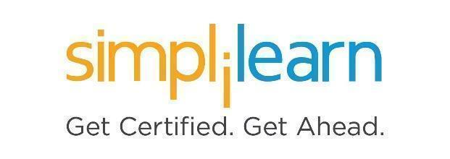

**Home Furnishing Application**

**Steps to be followed:**

1. Installing dependencies required for the project
2. Starting the MongoDB server and creating Rentfurlax schema in MongoDB
3. Setting Python project
   1. Creating a workspace for VS Code
   2. Creating Virtual Environment
   3. Installing dependencies
   4. Creating a project in VS Code
   5. Creating an app within project
   6. Updating respective files for code
4. Executing the projects and testing in POSTMAN

**Step 1: Installing dependencies required for the project**

1. Please ensure that the following tools are installed in your system:

* Python 3.x
* Visual Studio Code
* Django
* Django_rest_framework
* Djongo
* pymongo
* MongoDB
* Postman Client

1. Download the following GitHub repository:

**https://github.com/Simplilearn-Edu/PythonFSDCapstone1**

**Step 2: Starting the MongoDB server and creating the rentfurlax schema**

* 1. Open the terminal, and run the following command to check the MySQL server’s status:

**mongod --version**

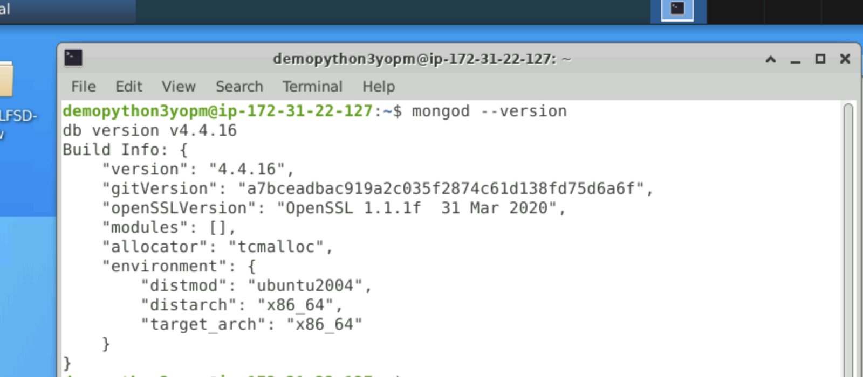

* 1. Run the following command to start the MongoDB server from the terminal  
     **sudo mongod**

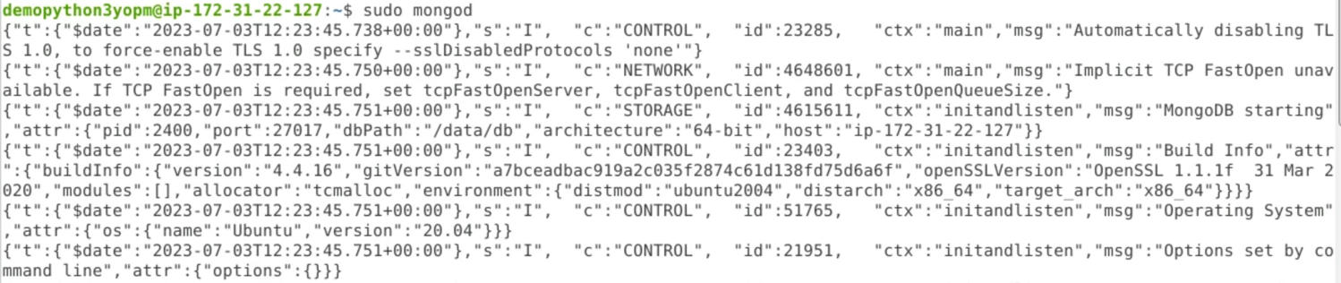

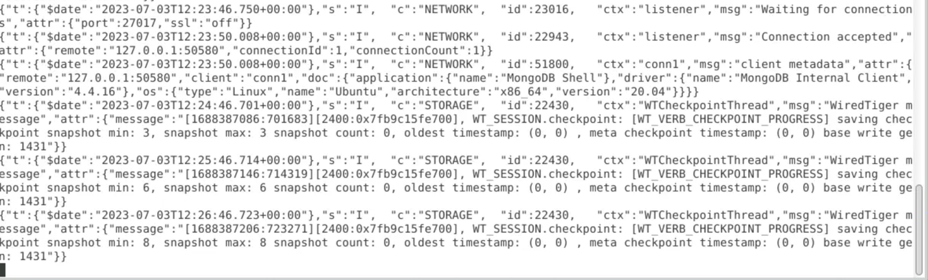

NOTE: Do not close this terminal as this is the Mongo server running

* 1. Open another terminal and use the following command to start the Mongo shell:

**sudo mongo**

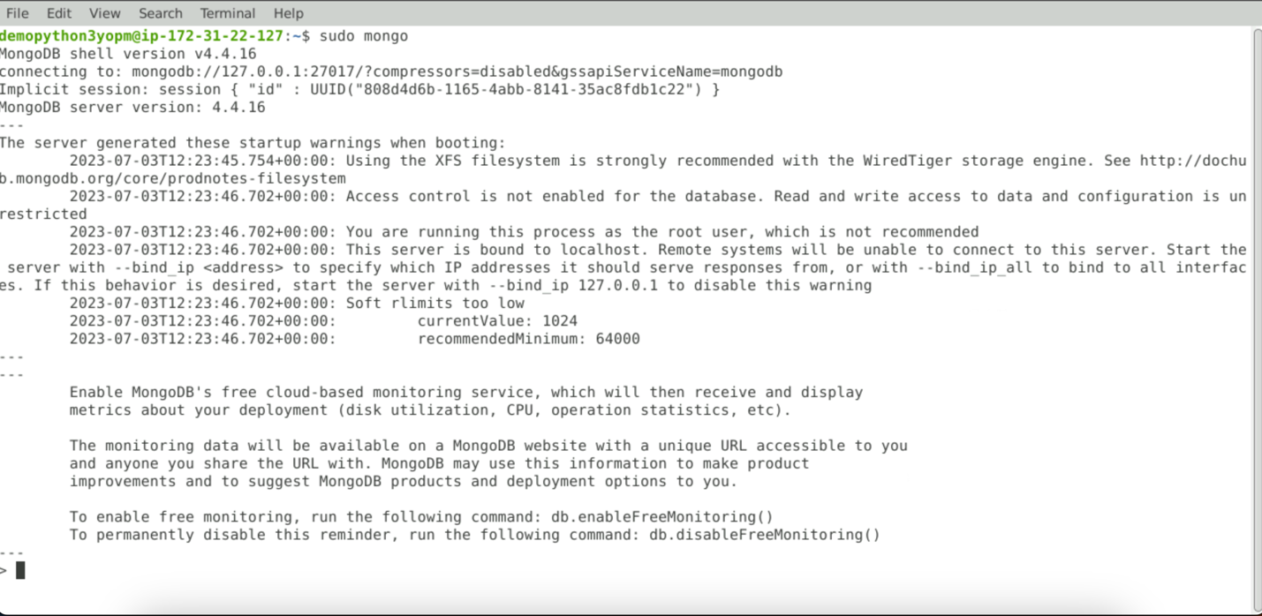

* 1. Once the Mongo shell is up and running, run the below command to see existing databases:  
     **show dbs**  
     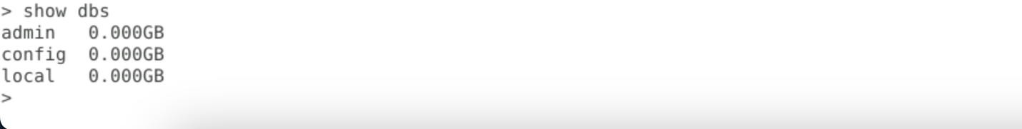
  2. To create a database, execute the below command:  
     **create database rentfurlax**



* 1. To see existing collections if any, execute the below command (It will be empty):

**show collections**  
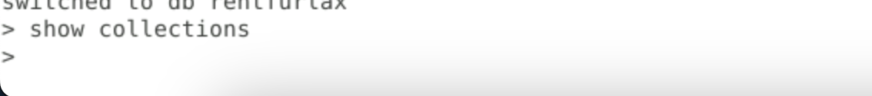

**Step 3: Creating workspace for VS code**

* 1. On Desktop -> right click -> select Create Folder  
     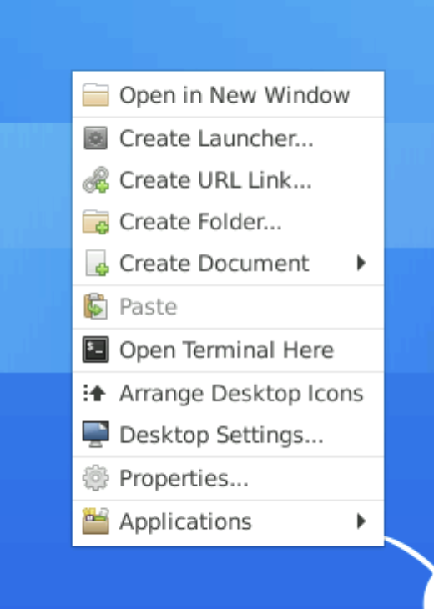
  2. Give folder name as follows  
     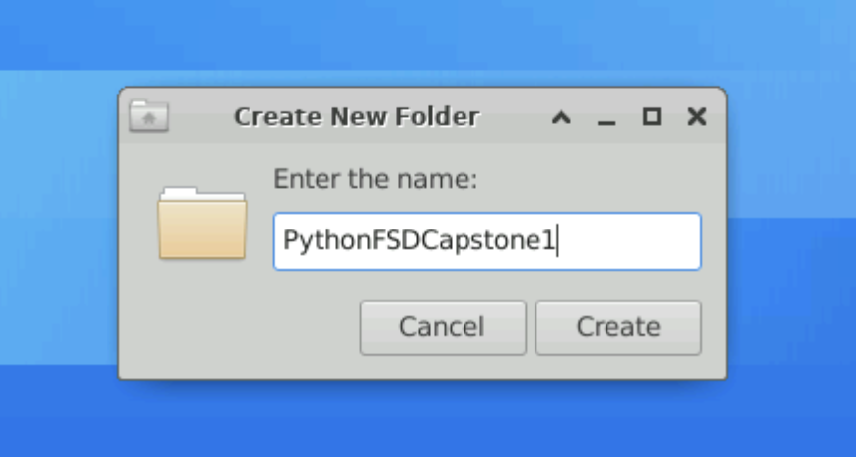
  3. Open Visual Studio Code and click on **File -> Open Folder**  
     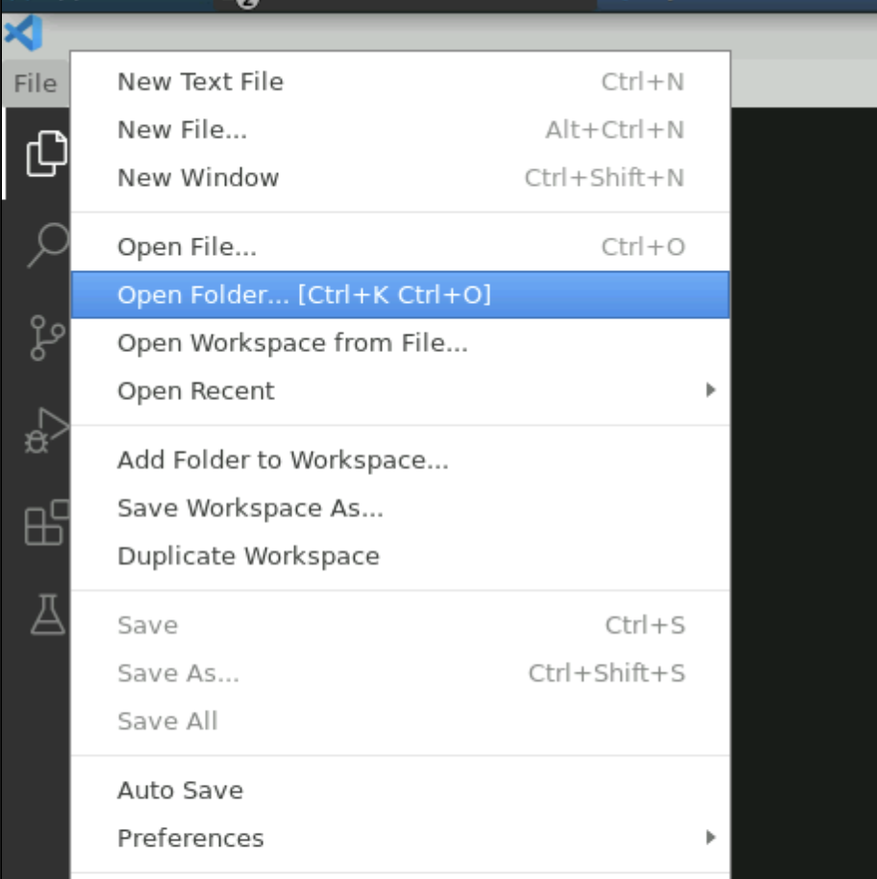
  4. Select the folder created in the previous step and click Open:

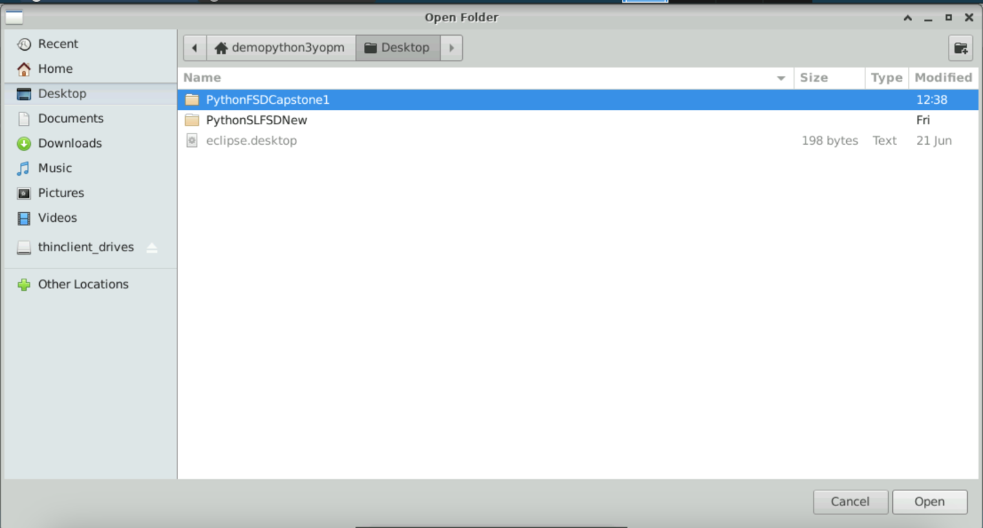

* 1. Once the folder is opened in VSCode, right-click within Explorer as shown and click **Open in Integrated Terminal**

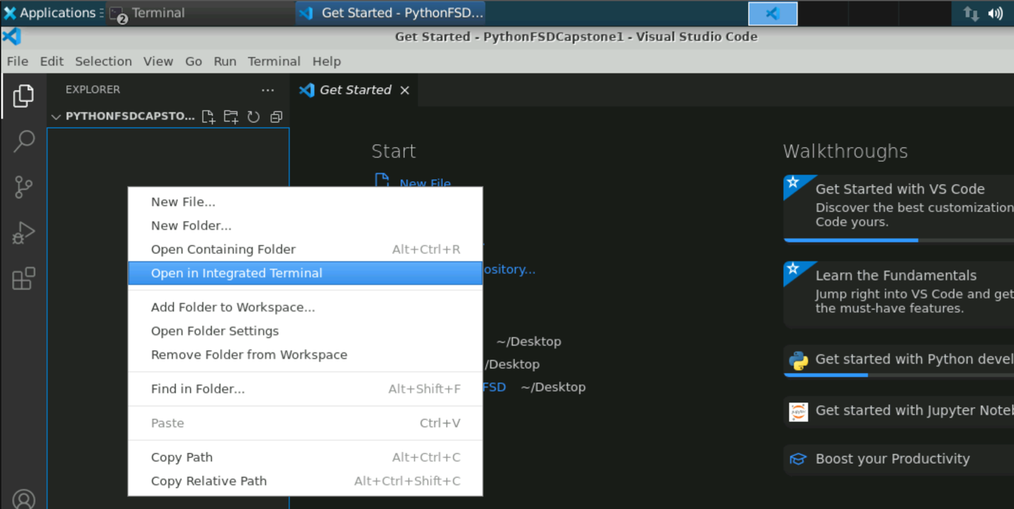

* 1. Once the terminal is open execute the below command to create a virtual environment and a folder will be created in the explorer as shown below:

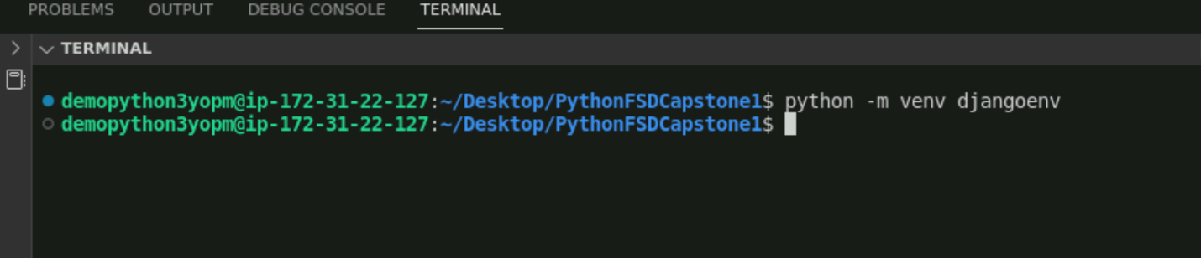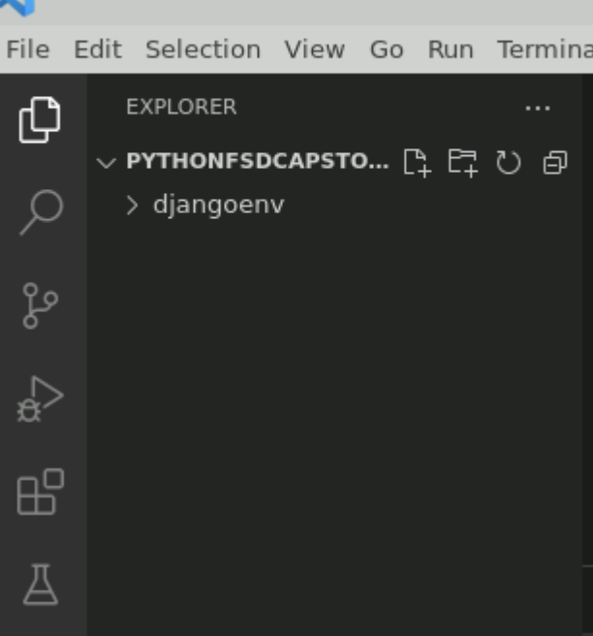

* 1. To activate the virtual environment, execute the below command:  
     **source djangoenv/bin/activate**  
     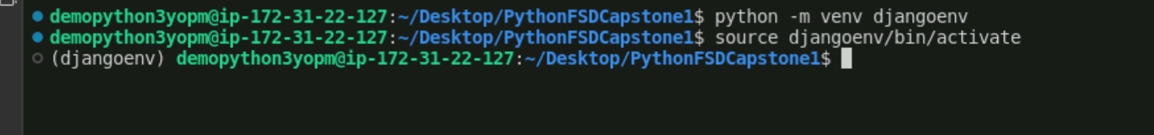
  2. Once the environment is activated, execute the below commands to install the dependencies for the rest framework:  
     **pip install django==3.1.14**  
     **pip install djangorestframework==3.13.1**   
       
       
     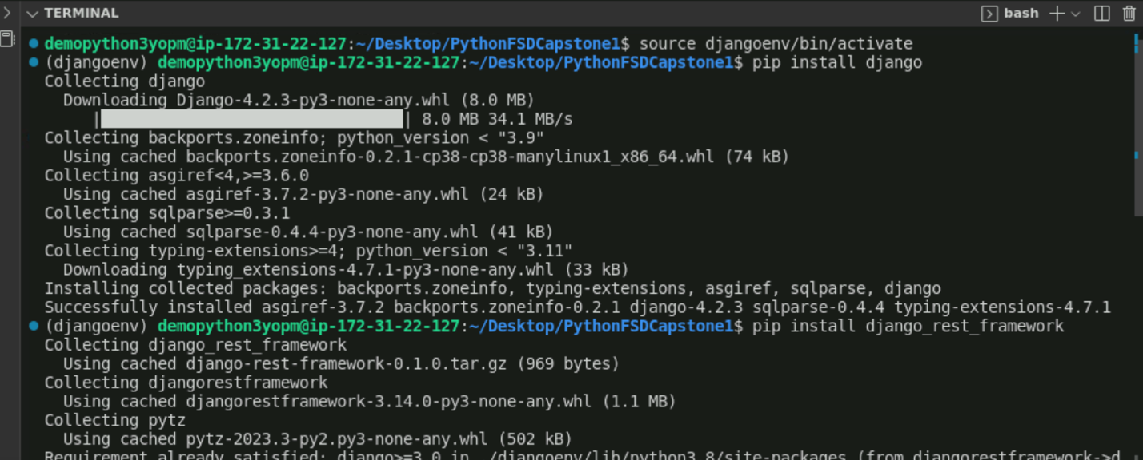
  3. Check the django-admin version as follows:  
     **django-admin version**  
     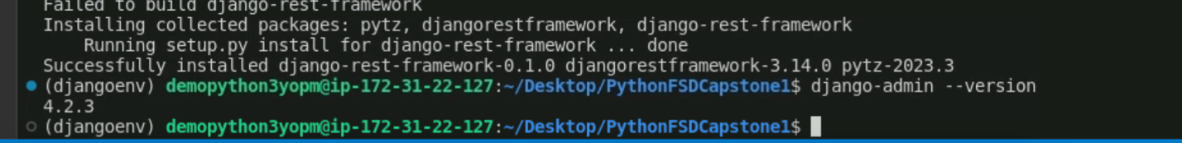

pip install setuptools

pip install disutils

* 1. Create a Django project by executing the below command:  
     **django-admin startproject capstone1**  
     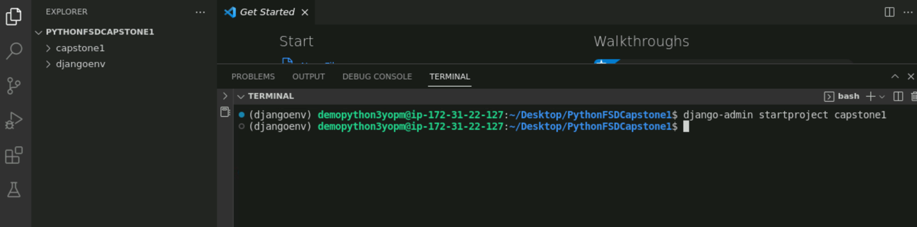
  2. Execute the project by entering the capstone1 folder and executing the commands below. The server should be up and running and the project available at **localhost:8000** as follows:  
       
     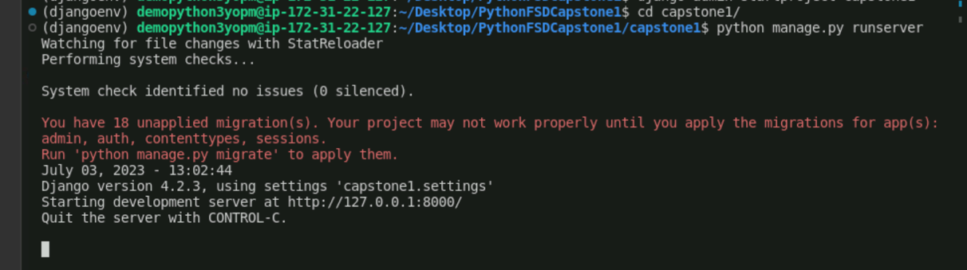  
       
     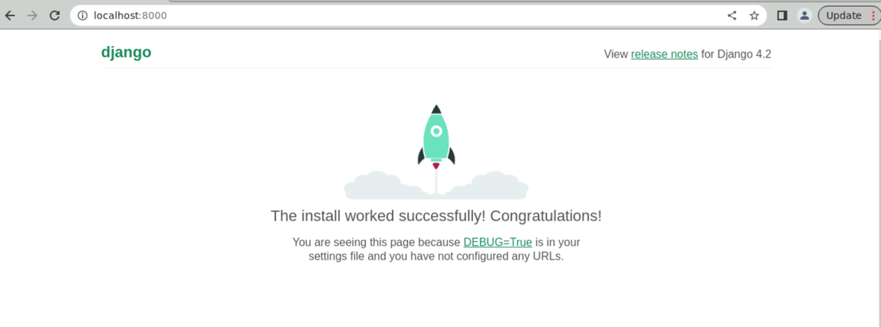
  3. Now stop the server by hitting **ctrl+Z** and execute the below commands to install dependencies for connecting with Mongodb:  
     **pip install djongo==1.3.6  
     pip install pymongo==3.12.3**  
     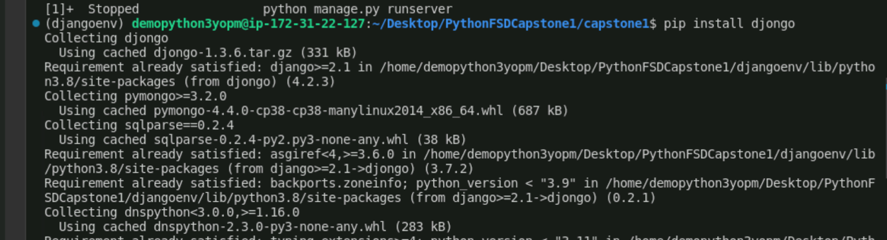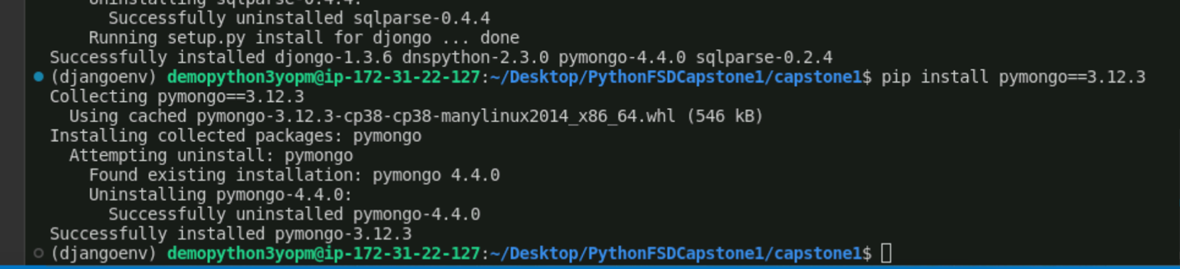
  4. Once dependencies are successfully installed, create an app within the **capstone1** folder as follows. It will create an app within the package explorer:  
     **django-admin startapp rentfurlax**  
       
     

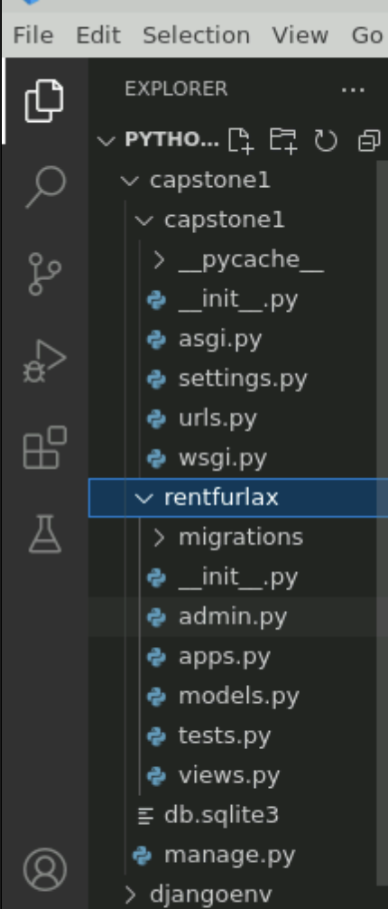

* 1. Make changes in the settings.py files for database configuration, adding apps and the authentication framework as follows:  
       
     **INSTALLED_APPS = [**

**'django.contrib.admin',**

**'django.contrib.auth',**

**'django.contrib.contenttypes',**

**'django.contrib.sessions',**

**'django.contrib.messages',**

**'django.contrib.staticfiles',**

**'rest_framework',**

**'rentfurlax'**

**]  
  
DATABASES = {**

**'default': {**

**'ENGINE': 'djongo',**

**'NAME': 'rentfurlax',**

**'HOST': '127.0.0.1',**

**'PORT': 27017,**

**}**

**}  
  
In the last add below line  
REST_FRAMEWORK = {**

**'DEFAULT_AUTHENTICATION_CLASSES': [**

**'rest_framework.authentication.BasicAuthentication',**

**]**

**}**

* 1. Create urls.py and serializers.py files within the rentfurlax folder as follows:  
     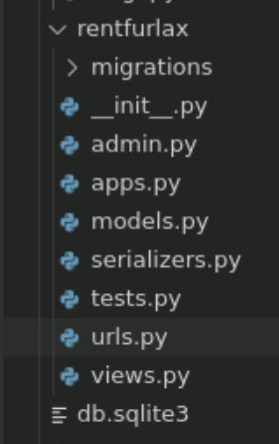
  2. Update **models.py** to include the various models required for your project

(Refer to GitHub repo for code)

* 1. Run the below commands to migrate models to the database   
     **python manage.py makemigrations  
     python manage.py migrate**  
       
     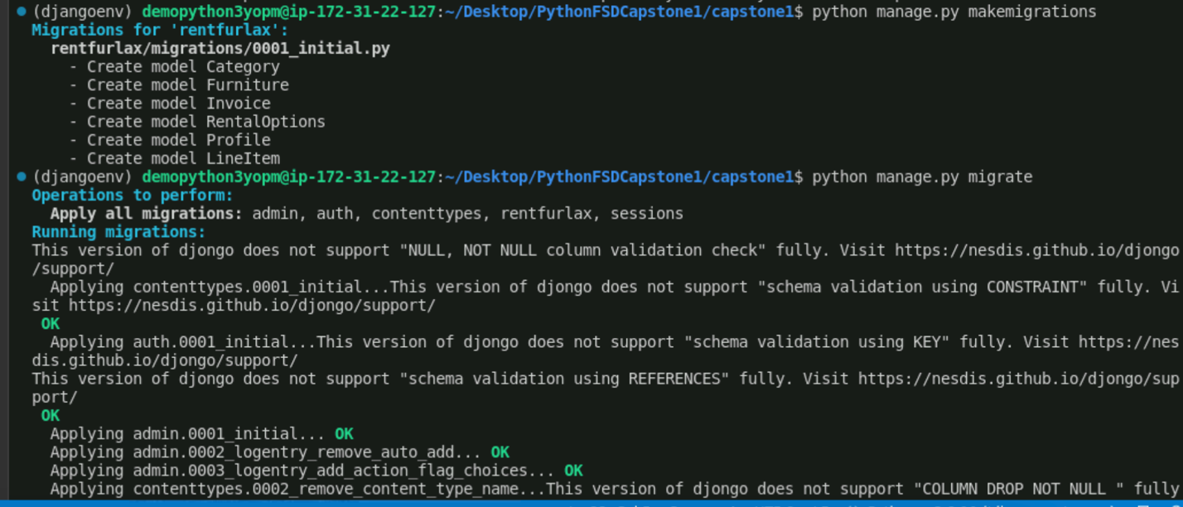
  2. Check Mongo shell for the collections created mapping with the models

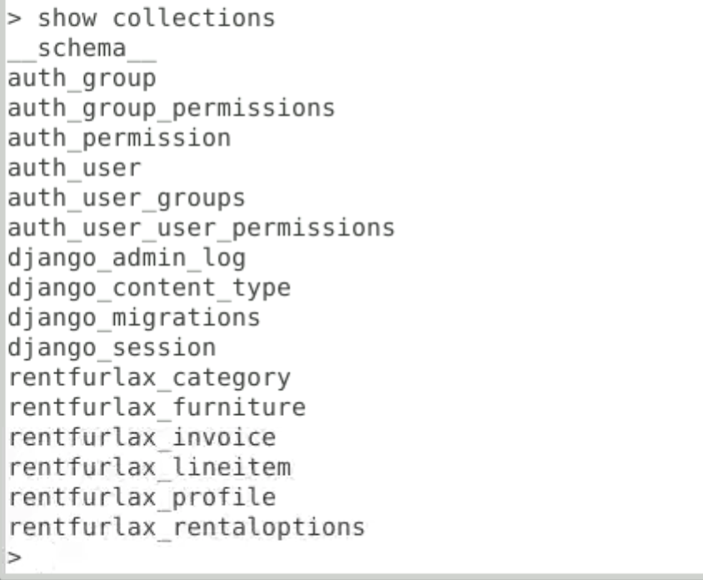

* 1. Update serializers.py and views.py (Refer to GitHub repo for code)
  2. Update root urls.py to include rentfurlax.urls as follows:  
      **from django.contrib import admin**

**from django.urls import path, include**

**from rentfurlax.views import \***

**urlpatterns = [**

**path('admin/', admin.site.urls),**

**path('', include('rentfurlax.urls')),**

**]**

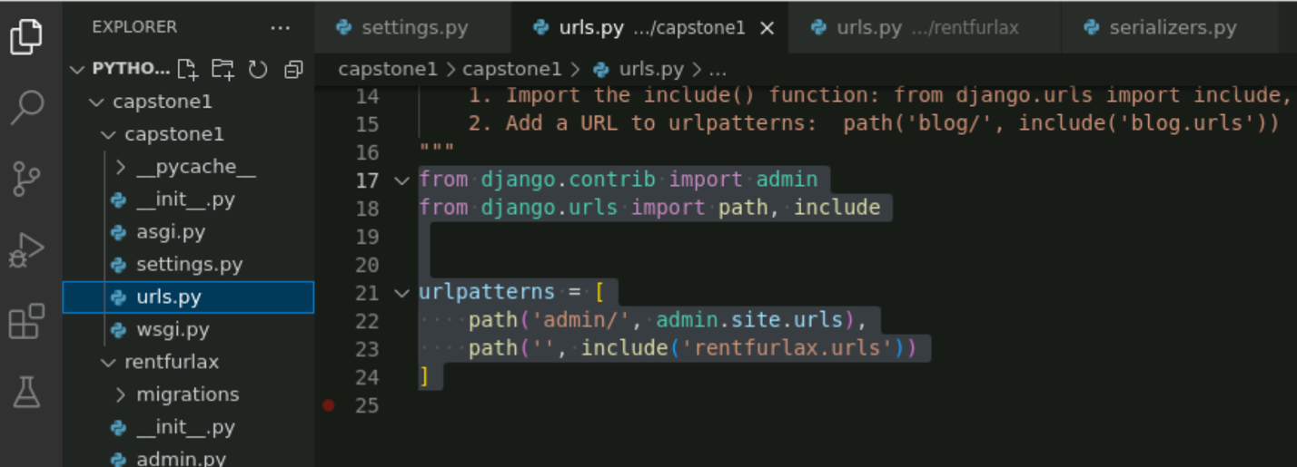

* 1. Run the project by executing the command   
     **python manage.py runserver**
  2. See the output on the browser as follows:

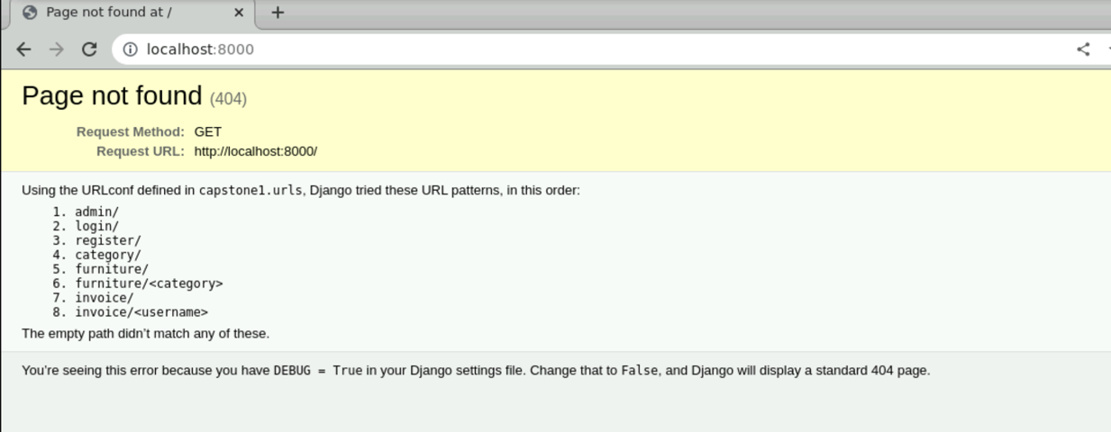

**Step 4: Executing the projects and testing in POSTMAN**

1. Open Postman
2. Register a customer:
   1. Failure message:  
      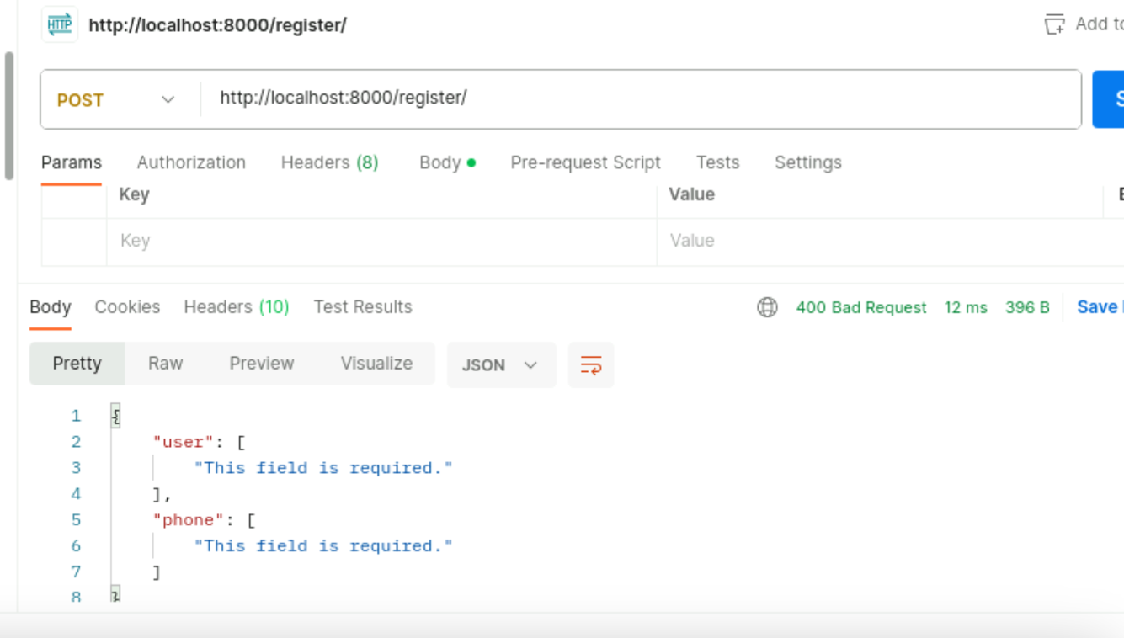
   2. Success message :   
      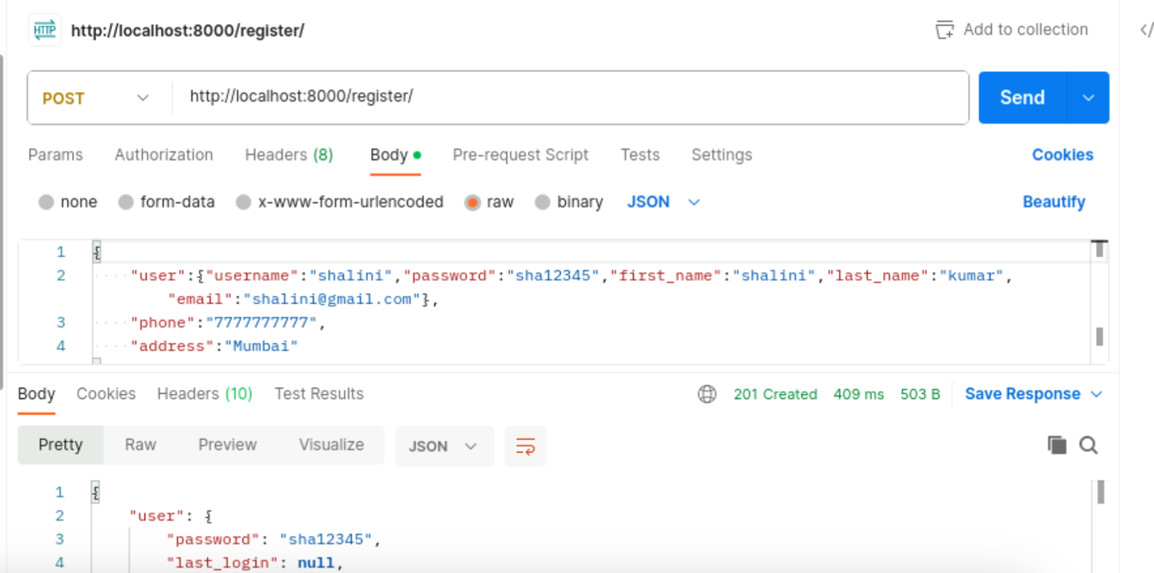
   3. Check in the database the record exists  
      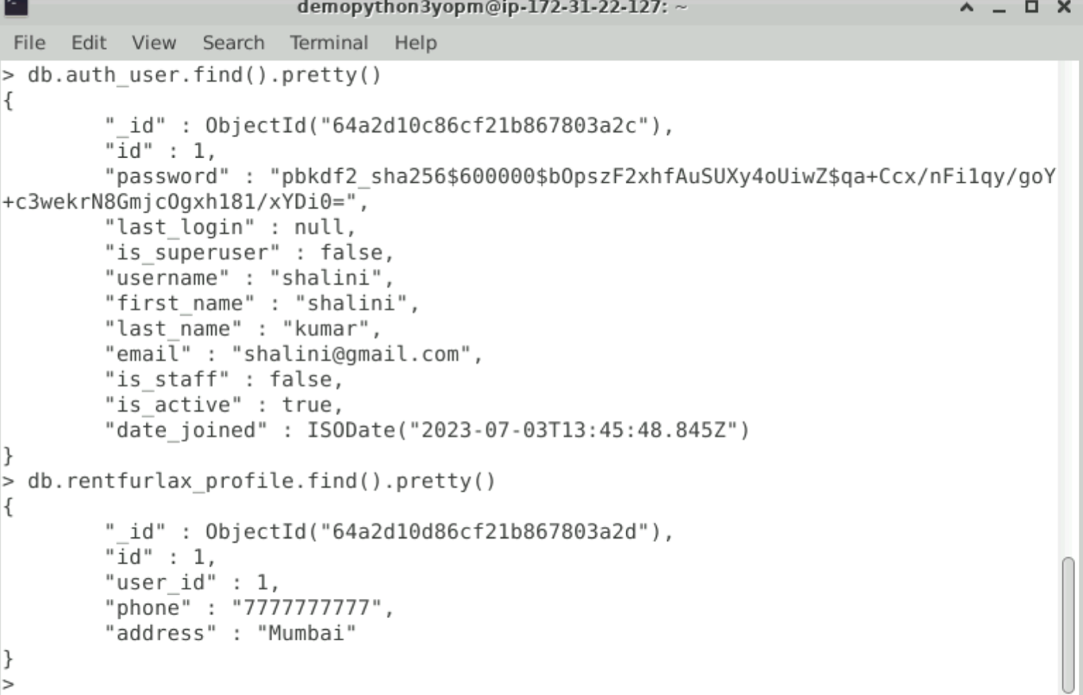
   4. If the same credentials exist, then give the following error:  
      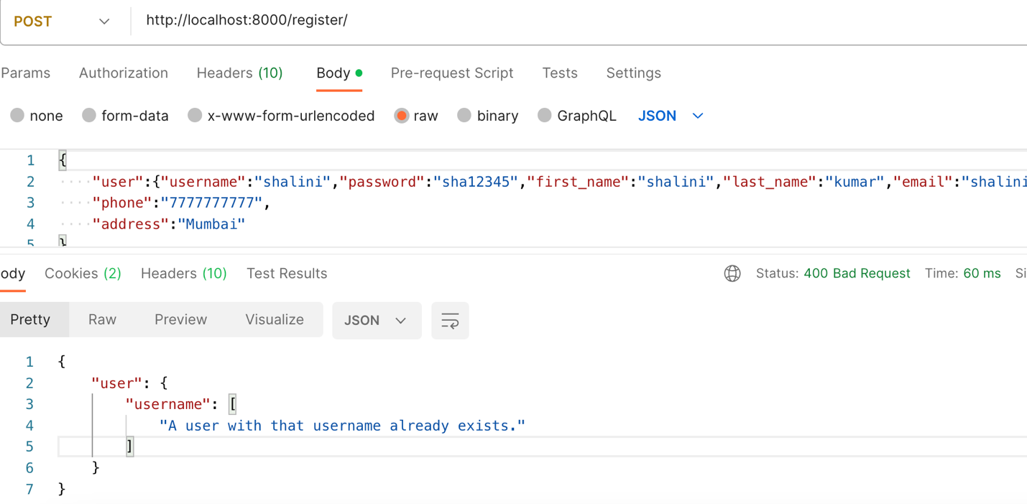
3. POST /login
   1. Success  
      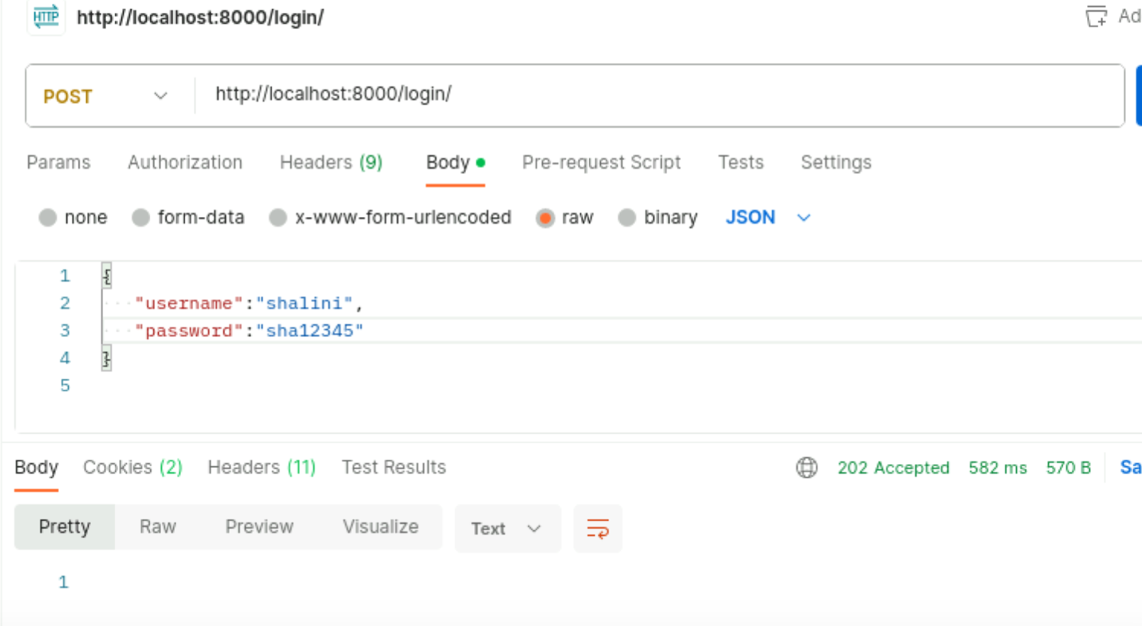
   2. failure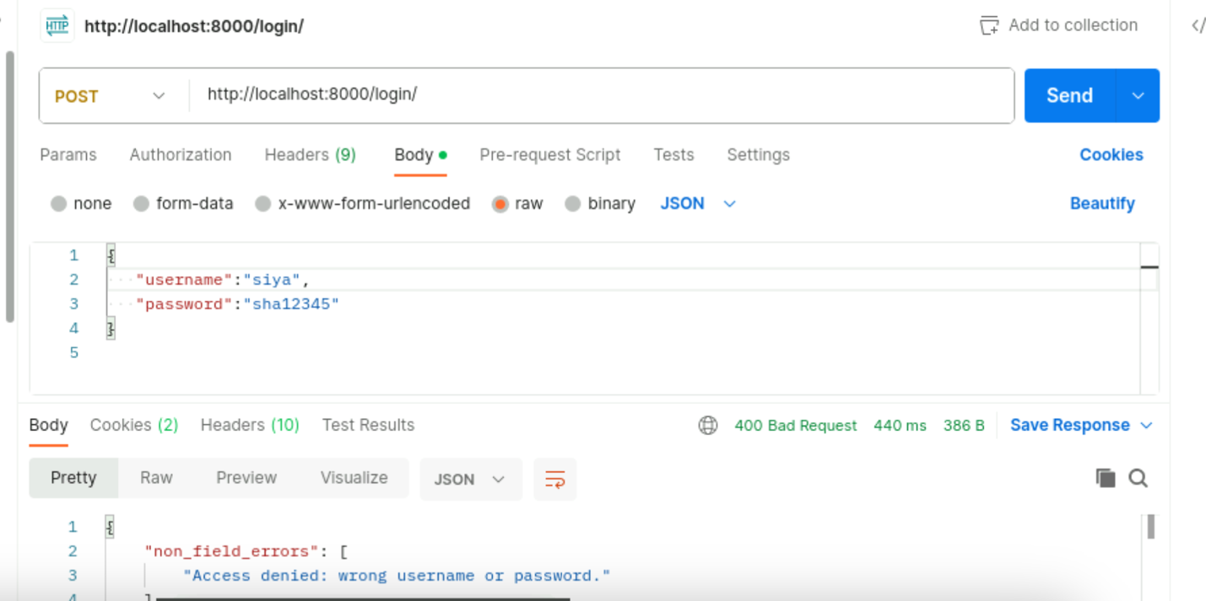
4. POST /category  
   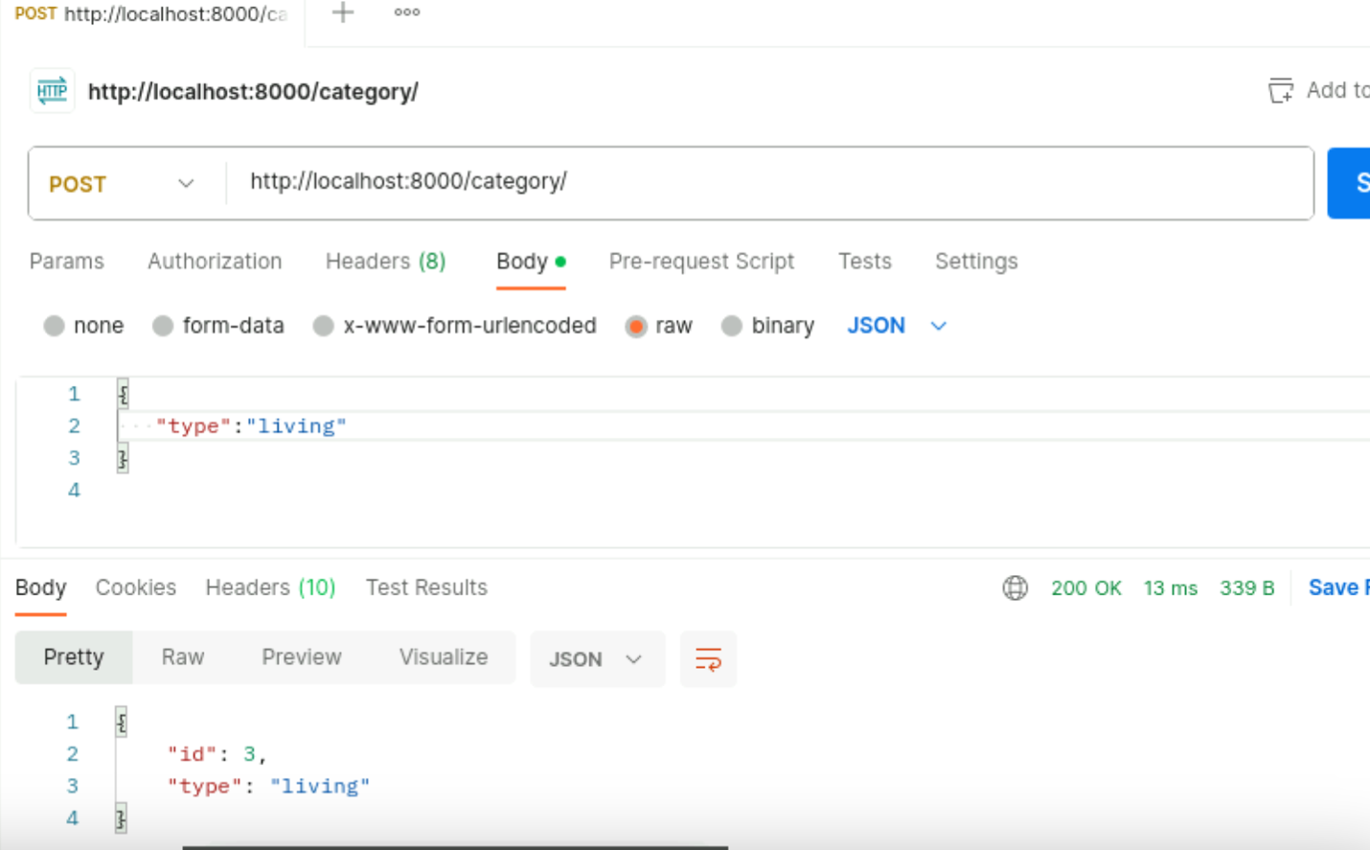
5. GET /category

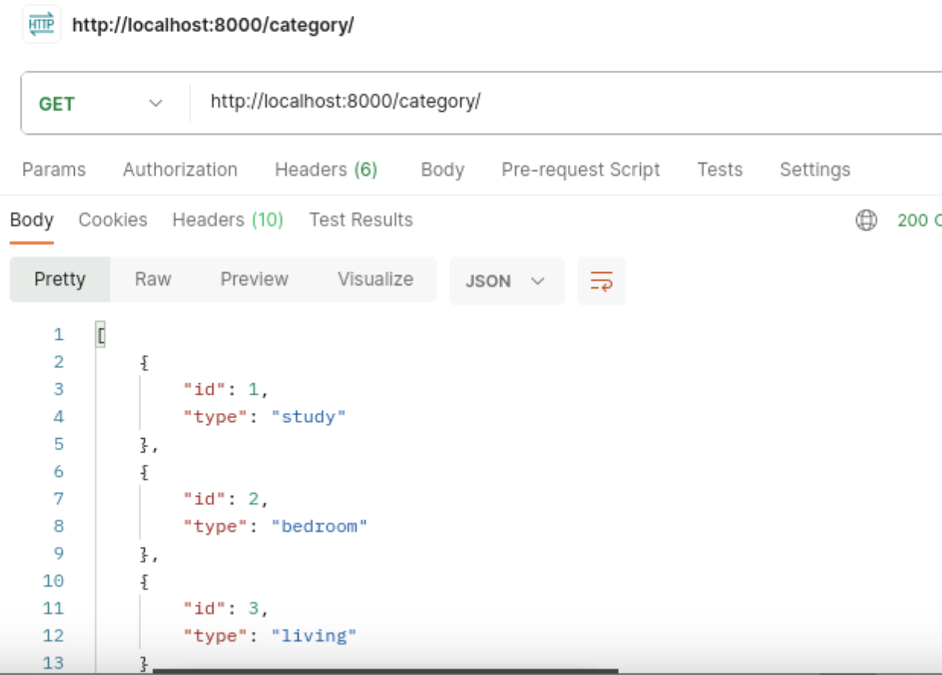

1. POST /furniture  
     
   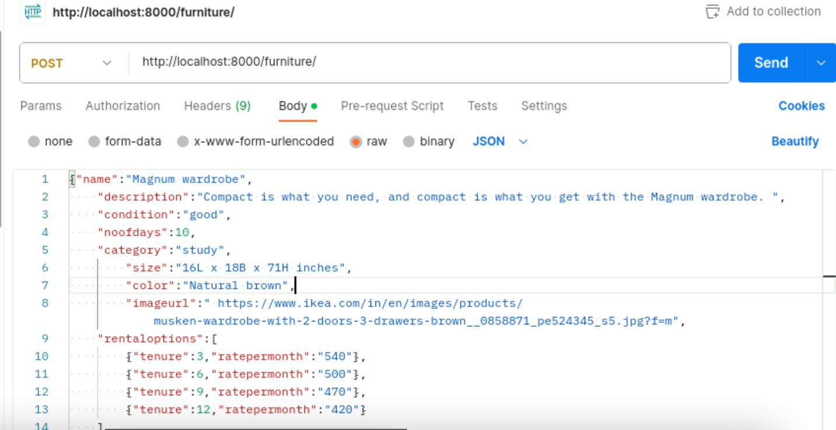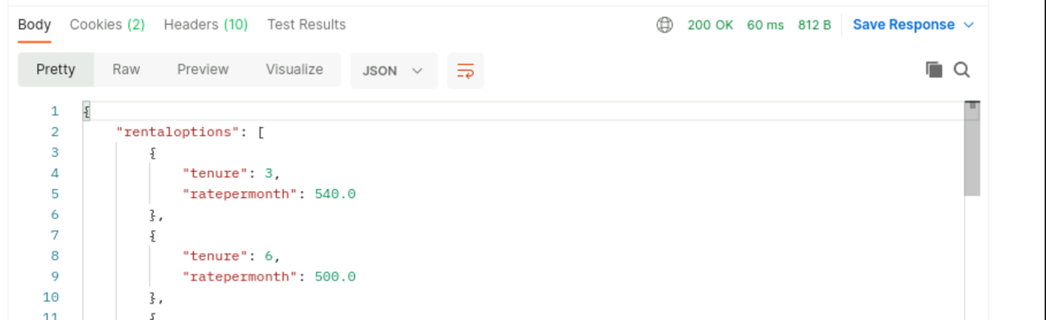

Check in database  
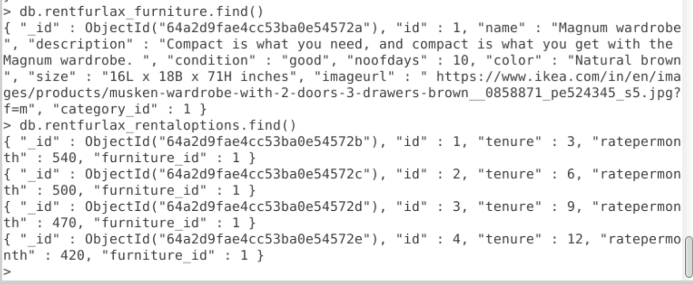

1. GET furniture/study  
   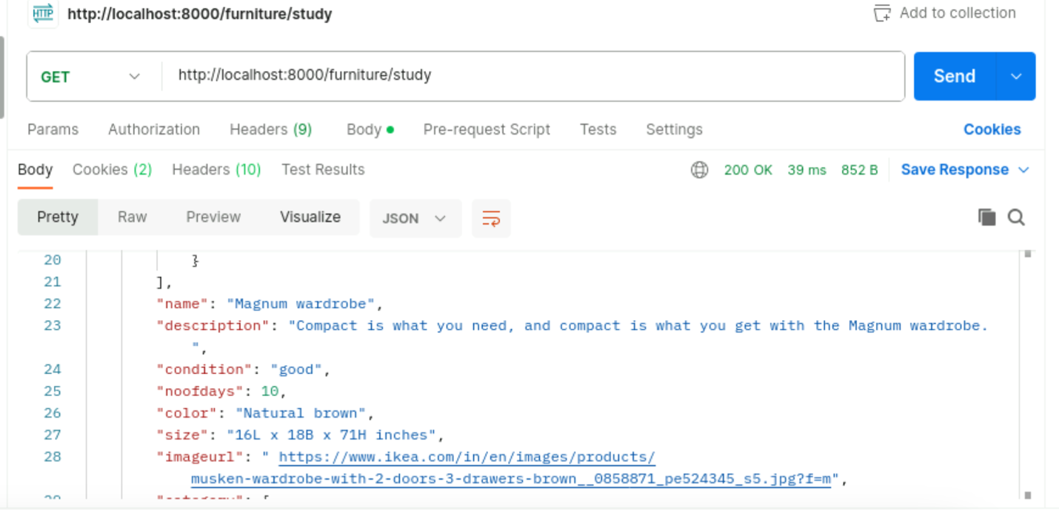
2. GET furniture/bedroom  
   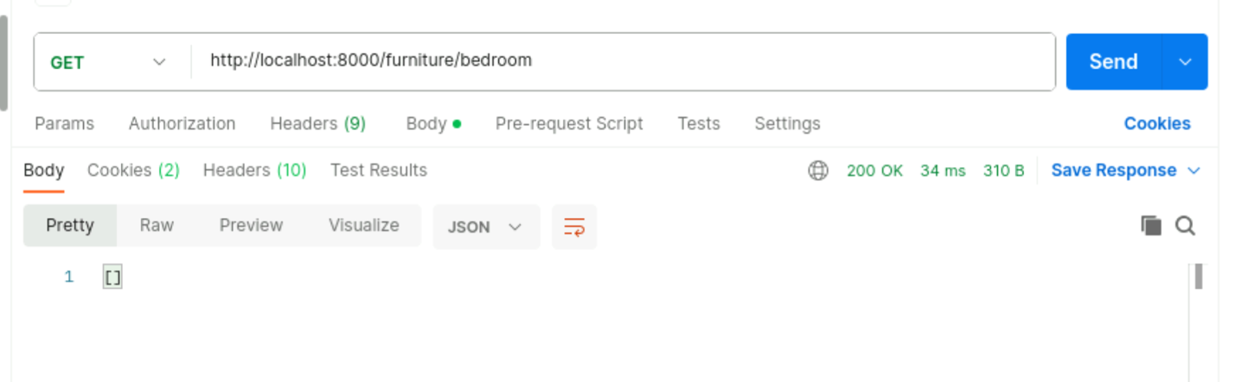
3. **POST invoice/  
   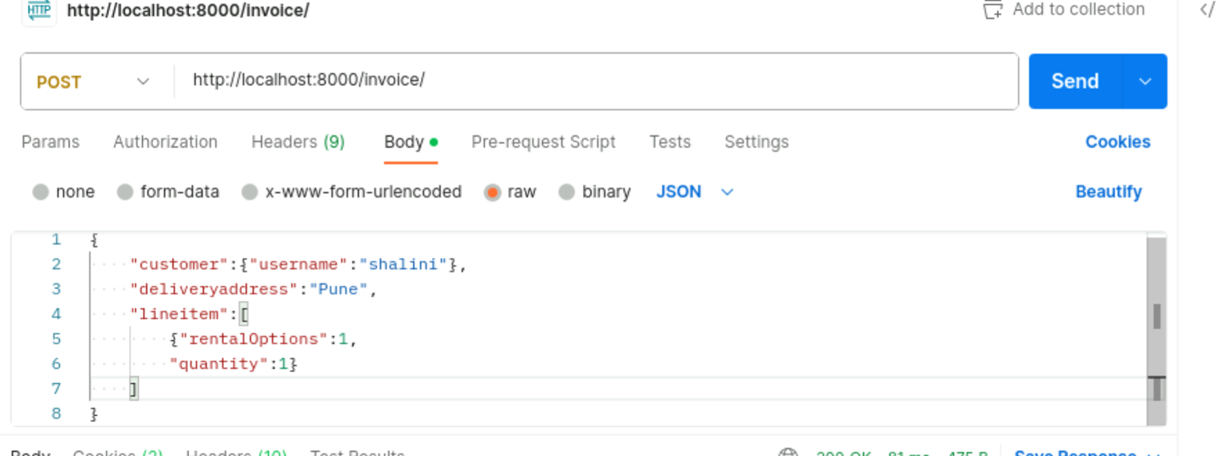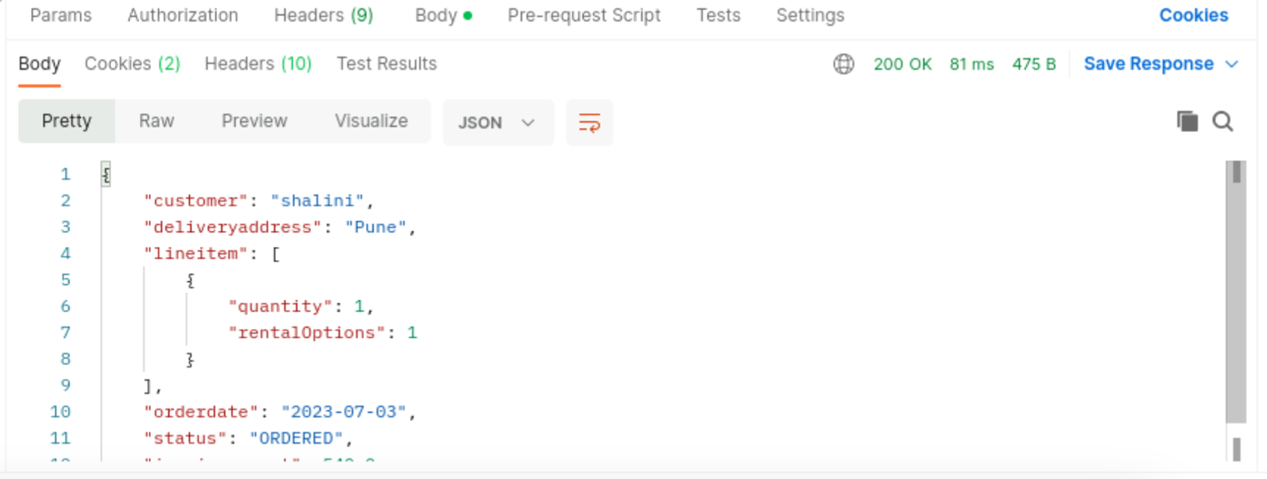**

**Check database  
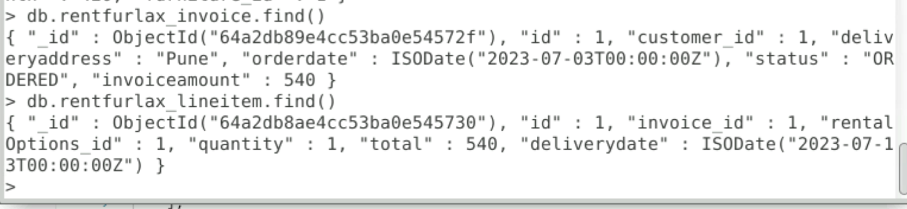**

1. **Get invoice/Shalini  
   